Computer Language Coding Concepts

Inactive Command Object Redirection in a Diagram
Inactive command object redirection is explained in the article Inactive Command Object Redirection. The current article demonstrates the concept in a diagram.

The picture below displays an inactive command, that redirects its definition to another inactive command.

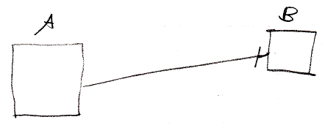

Inactive command symbol A is a square because it is an inactive command. Inactive command symbol A redirects its definition to the inactive command symbol B. Symbol B is also a square because it is also an inactive command. The redirection from command A to command B is displayed as a solid line, which is an object line. The direction of the line is indicated by a line dissector, close to symbol B. This line dissector is called an access mark. The redirection turns command A into a command reference to command definition B.

See also: Command Definition Object Redirection, Commands

Author & Copyright: Jan-Joost van Zon Date: August 10, 2008 – August 10, 2008 Location: Oosterhout, The Netherlands Status: Finished

